Parameter Image Calculation

Manual

Thomas Hackländer

Version 2.0, April 14, 2006
Author’s address

Priv.-Doz. Dr. med. Dipl.-Phys. Thomas Hackländer
IFTM Institut für Telematik in der Medizin GmbH
Höhscheider Weg 13
42269 Solingen
Germany

E-Mail: hacklaender@iftm.de

© 2006 Dr. Thomas Hackländer

Contents

1 Preface 5
2 Installation 7
3 Calculation of the T1 Parameter Image 9
4 Calculation of the T2 and Proton Density Parameter Images 11
5 Post Processing of the Parameter Images 13
5.1 Selective Median Filter 13
5.2 Selective Smooth Filter 13
5.3 Full Window 13
5.4 To Square Image 13

Preface
The simulation calculates synthetic images based on parameter images of intrinsic physical parameters like T1 and T2 relaxation times, proton density, susceptibility and flow velocity. The pixel values of these images are not measured as signal intensities but the numerical values of the intrinsic parameters of the body at that position. For each example case the parameter images have to be derived from a real-world examination once.
As in real-world examinations the signal intensity and contrast of the synthetic images depend on these intrinsic, as well as on extrinsic parameters. Besides others these are pulse timing parameters, field of view, slice thickness, type of RF coil, artefacts and display variables. To achieve such a realistic simulation the parameter images are processed in four steps:
- Calculation of an intensity image instead of the real-world object.
- Superposition of artefacts, e.g. noise, in the image space.
- Transform of the intensity image into k-space.
- Processing of k-space analog to a real–world MR scanner.
The parameter images are imported as DICOM images. In the current implementation only the T1, T2 and proton density images are used for calculation. The user selects a pulse sequence and appropriate parameter settings. At that point, the simulation generates an image in the image space. To simulate motion artefacts this image is manipulated. If k-space manipulations like oversampling are necessary, the resulting image is converted into k-space by a Fourier transform. These manipulation were carried out in k-space. The result is reconverted into the image space by an inverse Fourier transform. The remaining steps correspond to a real-world MR scanner.
The pixel values of the parameter images are the numerical values of the corresponding intrinsic physical parameter. With these numerical values the signal intensity calculation in the image space is done by means of a known mathematical relation for the chosen pulse sequence

Calculation of the parameter images is done by using the freeware program ImageJ. It can be downloaded at http://rsb.info.nih.gov/ij/. The necessary algorithms are implemented as plugins for ImageJ. The description of the plugins is given in this manual.
To produce a set of parameter images for the Virtual MR Scanner the following steps should be perfomed:
- Do the patient measure using the examination sequences described beneath.
- For T1 and T2 calculation do separately
  - Load the relevant DICOM images using the standard ImageJ open command.
  - Create a stack out of these images
  - Run the parameter image calculation plugin
  - Perform filtering of the result parameter image to reduce the number of pixel with erroneous pixel values. This can be done by filters of ImageJ or by any other graphic program capable of processing 16 bit greyscale images.
  - Store the final image as 16 Bit TIFF.
To make the parameter images usable for the Virtual MR Scanner an index file has to be prepared by a text editor residing in the same directory as the calculated parameter images. The file is a standard Java property file containing each property in a separate line. Each property consists of a key the “=” character and the value (see the following example):
name.t1 = t1.tif
name.t2 = t2.tif
name.pd = pd.tif
name.filename = brain_en.htm
name.title = Brain: No Pathology
For the first three properties the chosen filenames of the parameter images has to be given as the value. The next property contains an (optional) name of a HTML file describing the pathology of the examination. The title property corresponds to the patient name in a real world scanner in is displayed in the Virtual MR Scanner accordingly.

Installation
  - Windows
First make sure, that Java 1.4 or higher is installed on your PC. To test type in the Command-Window:
java –version
If Java is installed, a message stating the version is displayed. If Java is not installed you can download the current version from:
http://java.sun.com/j2se
Next download the Parameter Image Calculator software from Sourceforge
http://sourceforge.net/projects/vmri
The file includes the “bin” version as well as the source files and the complete Netbeans project folder to compile the source files.
After decompressing the ZIP archive a folder containing all necessary files is available. Start ImageJ by double clicking the file
Run_ImageJ.bat
All calculation and filtering is done by plugins, which could be found under the ImageJ menu
Plugins/ParameterImages.
Alternatively the folder ParameterImages residing in the Plugins folder could be copied to another ImageJ installation. All relevant classes are included in this folder.

  - Macintosh OS X
Download the Parameter Image Calculator software from Sourceforge
http://sourceforge.net/projects/vmri
The file includes the “bin” version as well as the source files and the complete Netbeans project folder to compile the source files.
After decompressing the ZIP archive a folder containing all necessary files is available. Start ImageJ by double clicking the file
Run_ImageJ_mac
All calculation and filtering is done by plugins, which could be found under the ImageJ menu
Plugins/ParameterImages.
Alternatively the folder ParameterImages residing in the Plugins folder could be copied to another ImageJ installation. All relevant classes are included in this folder.

  - Macintosh OS 9
Not tested. Could be problematic because Java 1.4.x was not available for OS 9 as a standard option.

  - Linux
Not tested. Should be done similar to the Windows installation. The downloadable files are pure Java and not operating system specific.

Calculation of the T1 Parameter Image
Patient Examination
For patient examination a non spoiled, non refocused gradient echo sequence should be used. Suitable parameters are:
Repetition time TR = 30 ms
Echo time TE = 6 ms
Flip angle α = 80° and 10°
Between the two measurements with different flip angles no recalibration of the MR scanner is allowed. As the measurement with the higher flip angle results in a lower overall signal intensity of the image, this measurement should be performed first. This results to an optimal signal intensity of the first measured image and a slightly to high signal intensity of the second. Compared to the other order this gives a better signal to noise ratio of the parameter images.
In principle one can use 2D or 3D sequences for measurement, but 3D sequences are preferable, as they have a more homogenous distribution of the flip angles and therefore of the signal intensity through the z-dimension of the slice. For 2D sequences and higher flip angles the real mean signal intensity of the slice could be more than 2.5 times higher as expected by theory.

Mathematical Model
The signal intensity of a Spin-Echo sequence is given by
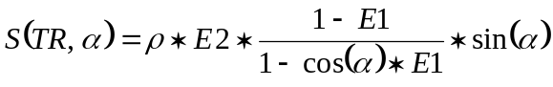
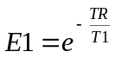
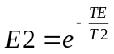
The T1 relaxation time could be calculated by measuring the same slice with the same pulse sequence but different flip angles:
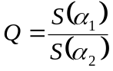
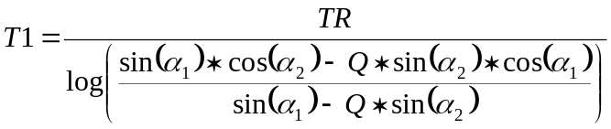

ImageJ Plugin
The plugin requires the selection of a 16 bit grayscale image.
When the plugin starts it asks for several parameters. Fill in the parameters of the pulse sequence used for patient examination.
The parameter Background Signal Intensity defines the lowest signal intensity necessary for calculation of the T1 parameter. Pixels with lower signal intensity will result in a T1 value of 0. In the dialog box the background signal intensity is guessed by calculating the mean of the pixel values of a square of 20 pixel size in the top left corner of the chosen stack. The value can be changed to any positive value.

The T1 parameter image contains the T1 relaxation time of each pixel measured in milliseconds.
The pixel values are limited to the interval from 0 to 8000.

Calculation of the T2 and Proton Density Parameter Images
Patient Examination
For patient examination a multi-echo Spin-Echo sequence should be used. The number of echos should be sufficient to make a least square fit of the signal intensities for each pixel. Suitable parameters are:
Repetition time TR = 5000 ms
Echo time TE = 20 -320 ms in 16 steps
Flip angle α = 10° and 80°

Mathematical Model
The signal intensity of a Spin-Echo sequence is given by
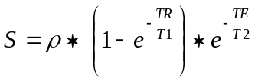
As TR is constant in a multi-echo sequence, the equation could be simplified to
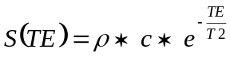
By logarithmise this expression one gets
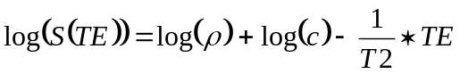
which could be fitted by a least-square algorithm to
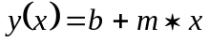
For each pixel the T2 parameter is given by
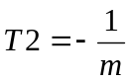
For the proton density ρ only relative value could be calculated
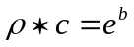
By scaling all pixels of the proton density parameter image to a maximum value of 100% the dependency of the factor c could be eliminated.

ImageJ Plugin
The plugin requires the selection of a 16 bit grayscale image.
When the plugin starts it asks for several parameters. Fill in the parameters of the pulse sequence used for patient examination.
The parameter Background Signal Intensity defines the lowest signal intensity necessary for calculation of the T2 parameter. Pixels with lower signal intensity will result in a T2 value of 0. In the dialog box the background signal intensity is guessed by calculating the mean of the pixel values of a square of 20 pixel size in the top left corner of the chosen stack. The value can be changed to any positive value.

The T2 parameter image contains the T2 relaxation time of each pixel measured in milliseconds.
The pixel values are limited to the interval from 0 to 8000.

The PD parameter image contains the proton density of each pixel measured in (percent * 10).
The pixel values are limited to the interval from 0 to 1000.

Post Processing of the Parameter Images

Selective Median Filter
The plugin replaces a subset of pixels with the median of the pixel values of the 8 surrounding nearest neighbors. Only those pixels whose values are higher than the median of the nearest neighbors multiplied by a given factor are processed.
The plugin could be used to smooth pixels with numerical errors in the calculation of the parameter images. Often these errors result in non physiological high pixel values.
The plugin requires the selection of a 16 bit grayscale image.

Selective Smooth Filter
The plugin replaces a subset of pixels with the weighted mean of the pixel values of the 48 surrounding nearest neighbors. Only those pixels whose values are lower than a given absolute value are processed.
The plugin could be used to smooth pixels with numerical errors in the calculation of the parameter images. Often these errors result in non physiological low or negative pixel values.
The plugin requires the selection of a 16 bit grayscale image.

Full Window
The plugin sets the window of the selected image to the interval of 0 up to a given upper limit.
The plugin requires the selection of a 16 bit grayscale image.

To Square Image
The plugin creates a new image of square size and copies the selected image onto the centre of newly created image. The size of the created image corresponds to the width or height of the selected image whichever is bigger.
The plugin requires the selection of a 16 bit grayscale image.

Appendix A: Using the Jar bundler under Macintosh OS X
First download the developer tools from the Apple Support site.
Run the Jar bundler
Developer/Applications/Java Tools/Jar Bundler
Use the following information to fill the dialog box:
Card: Build Information
Choose…
Select ij.jar File
Select ij.ImageJ as “Main Class”
Anti-alias Text
Anti-alias Graphics
JVM Version: 1.4*
Card: Build Information
Create Application…
Run_ImageJ_mac

